CS 255 System Design Document Template

This template lays out all the different sections that you need to complete for Project Two. Each section has guidance to prompt your thinking. You will need to continually reference the interview transcript as you work to make sure that you are addressing your client’s needs. There is no required length for the final document. Instead the goal is to complete each section based on what your client’s needs are. Remove this note when you are finished, and replace all bracketed text with the relevant information.

UML Diagrams

UML Use Case Diagram

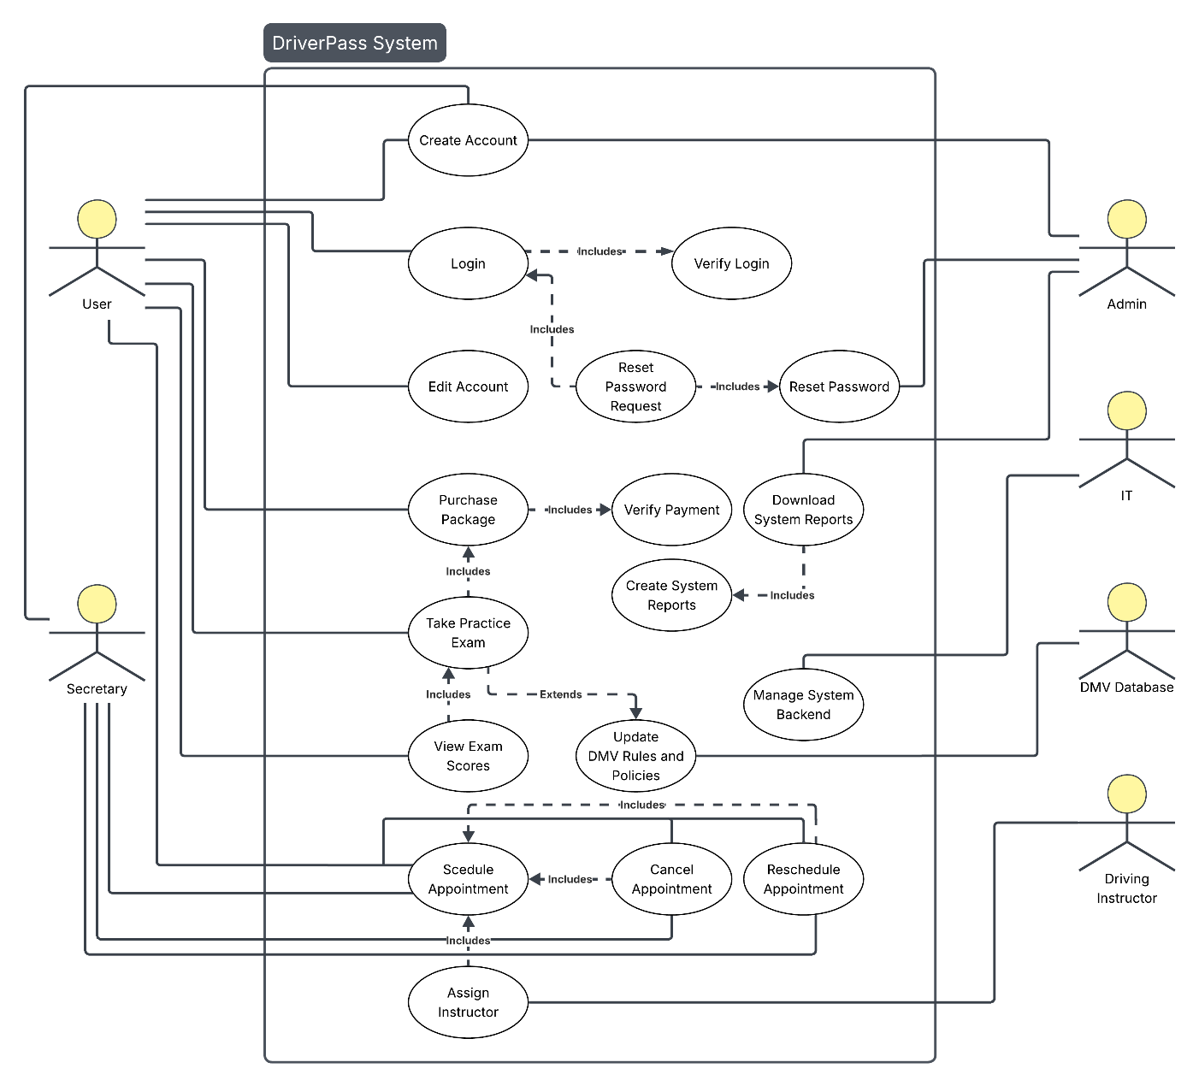

UML Activity Diagrams

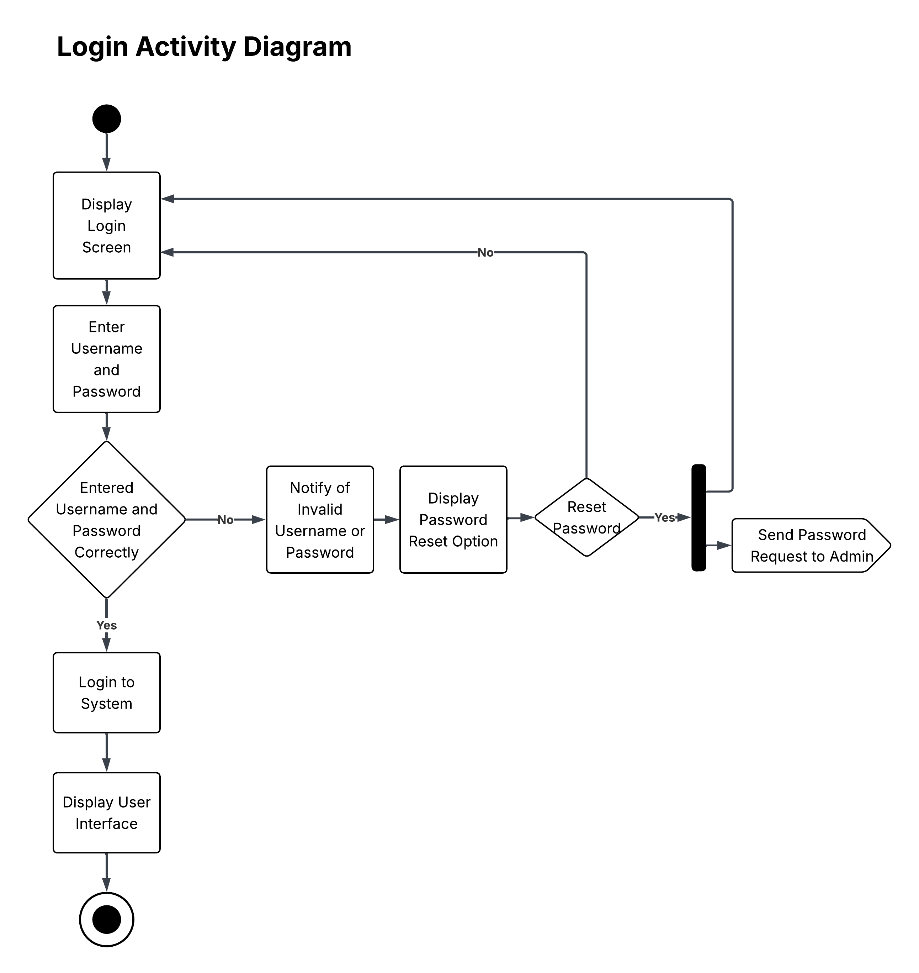

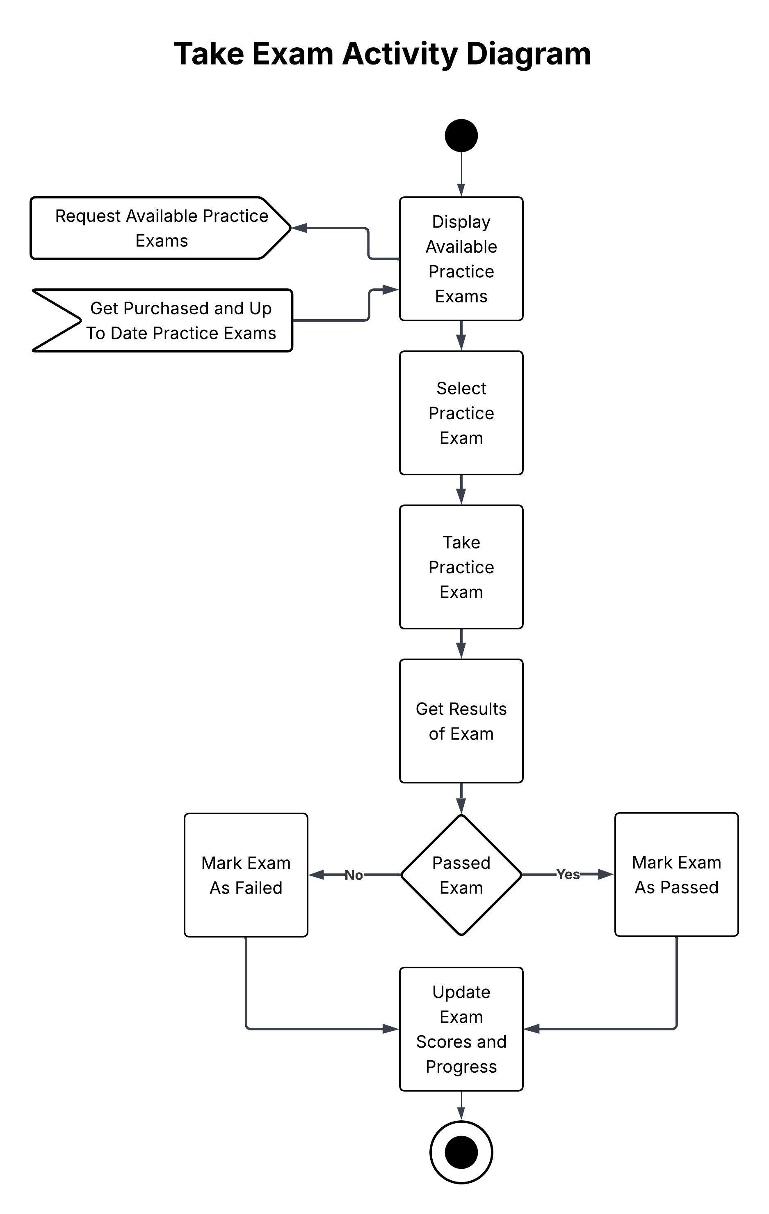

UML Sequence Diagram

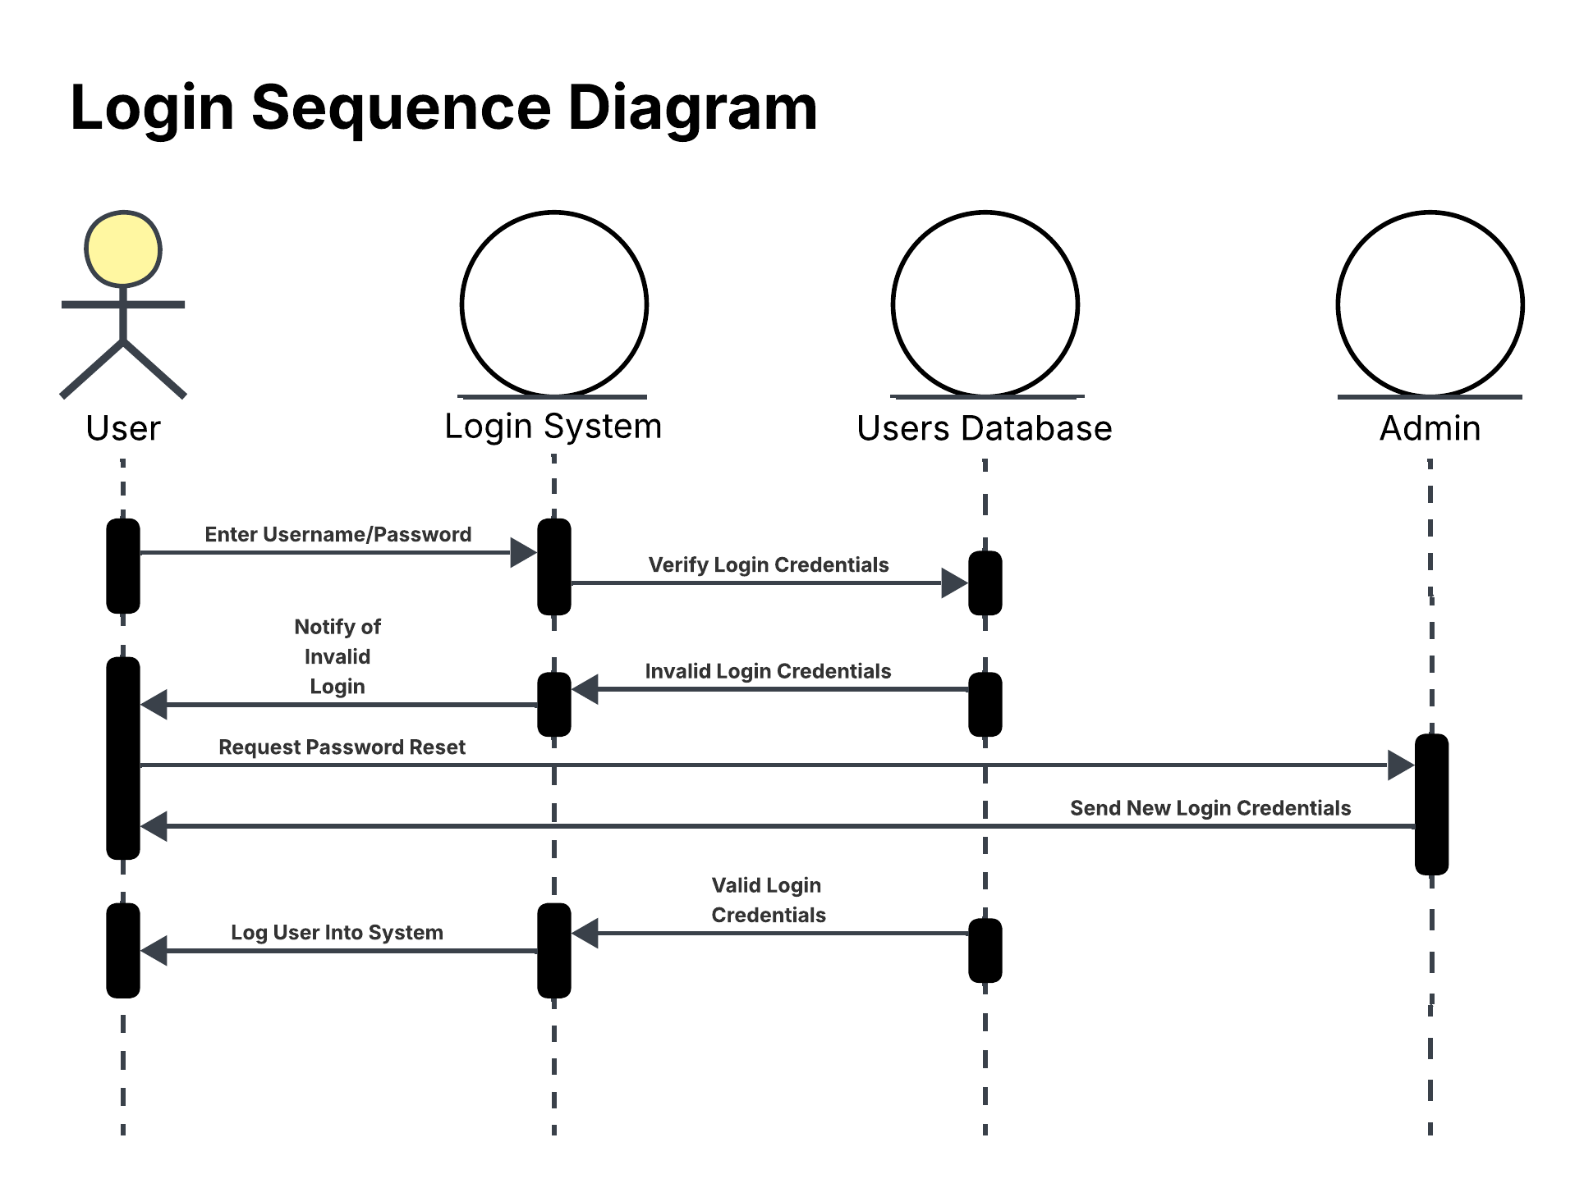

UML Class Diagram

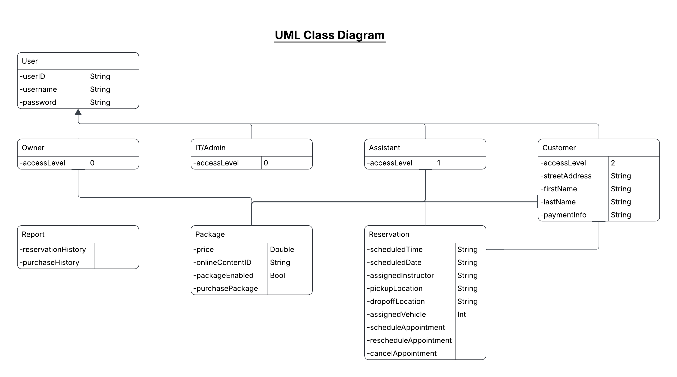

Technical Requirements
All of the employees within driver pass will need access to hardware, either a computer or phone, though preferably a computer with Windows as the operating system. These computers need to be able to access a browser, so a good internet connection is required as well.
For the system itself we will need to have a database with all of our users’ login information, package information, report data, and other important information the system needs access to. Ideally this will be stored on a cloud-based server we can rent. The same goes for the website itself, it should be run from a cloud-based server.
We also need to set up payments through a secure and well-known payment processor as it’s unrealistic for us to create our own system for that.

